Testing Track_YOL_Web Based Testing (E-Learning)
Web Application Testing Guide for Practitioner Level.
Chapter 1 describes the basics of Web Application Testing including the learning objective, overview of web testing, types of web testing and the testing criteria involved.
Learning Objective
This guide gives a complete coverage on Web-based application testing and enables the reader to learn the terminology, the process and types of testing web-based applications and related topics. As a result, one can have an increased comfort level and confidence in testing web-based applications.
Overview of Web Application Testing
Web Application Testing helps to ensure that the website tested is of high caliber and is complete by all means and various areas like browser compatibility, security, usability, performance and various web application testing methodologies should be incorporated to find weaknesses in required functionality. It also ensures that the Web Application is industry standards compliant and sufficient authentication and authorization mechanisms are in place.
Various types of testing that can be done on web application are Functional, Usability, Accessibility, Graphical user Interface, Interface, Database, Compatibility, Content Management System, Web Security, Standards Compliance, Performance, and Device Testing.
Testing criteria
The basic testing criteria to be followed while testing a Web Application are
Page Testing to check if every page is visited at least once in some test case.
Hyperlink Testing to check if every hyperlink from every page of the application is traversed at least once.
All Paths Testing to check if every path in the application is traversed at least once in some test case.
Chapter 2 describes about Functional Testing Overview and different functional testing types like Link Testing, Forms Testing, Database Testing, Cookies Testing and Business Workflow.
Overview: Functionality testing of software is testing conducted on a complete, integrated system to evaluate the system's compliance with its specified requirements. Functionality testing falls within the scope of black box testing, and as such, should require no knowledge of the inner design of the code or logic.
Functional Testing is classified into Link Testing, Forms Testing, Database Testing, Cookies Testing and Business Workflow Testing.

Link Testing
- Check that the link takes you to the page it said it would.
- Ensure to have no orphan pages (a page that has no links to it)
- Check all of your links to other websites
- Are all referenced websites or email addresses hyperlinked?
- If we have removed some of the pages from our own site, set up a custom 404 page that redirects your visitors to your home page (or a search page) when the user try to access a page that no longer exists.
- Check all mailto links and whether it reaches properly.
Forms Testing
Forms are the integral part of any web site. Forms are used to get information from users like a "contact us" page or newsletter sign up and is set to a temporary email address for testing. Users can submit the information through Forms and it helps the user to interact with them. Forms should be tested on all the pages of the web application and the conditions to be checked are
- Scripting checks on the form are working as expected i.e. Error message should be displayed when the mandatory fields in a form are left blank
- Check default values are being populated on page load/reload
- Check all the fields in the form are validated for wrong inputs
- Check Input longer than field is getting truncated.
- Is Command Button can be used for Hyperlinks and Continue Links ?
- Is all the data inside combo/list box are arranged in chronological order?
- Once submitted , the data in the forms is submitted to a live database or is linked to an working email address
- Forms are optimally formatted for better readability.
Database Testing
Database Testing is one of the major testing which involves checking tables, writing queries and procedures. Testing can be performed in web application or desktop and database can be used in the applications like SQL, Oracle, etc. Database Testing is very important because if the backend malfunctions, it may cause system deadlock, data corruption, data loss and bad performance. Testing activities will include,
- Test if any errors are shown while executing queries
- Data Integrity is maintained while creating, updating or deleting data in database.(Queries like, SELECT, INSERT, UPDATE, DELETE, etc are used to retrieve, modify and delete the records in the database)
- Check response time of queries and fine tune them if necessary.
- Test data retrieved from your database is shown accurately in your web application.
Cookies Testing
Cookies are small files used by websites to primarily remember active user sessions. Testing activities will include
- Check if the application is writing cookies properly or not.
- Test to make sure that no personal or sensitive data is stored in the cookie. If it is there in cookies, it should be in encrypted format.
- Close all browsers, delete all previously written cookies and disable the cookies from your browser settings. Navigate or use that part of web site which use cookies. It should display appropriate messages like "For smooth functioning of this site please enable cookies on your browser."
- Set browser options to prompt whenever cookie is being stored / saved in your system. Navigate or use that part of web site which use cookies. It will prompt and ask if you want to accept or reject the cookie. Application under test should display an appropriate message if you reject the cookies. Also, check that if pages are getting crashed or data is getting corrupted.
- Edit few cookies manually in notepad or some other editor. Make modifications like alter the cookie content, name of the cookie, change expiry date etc. Now, test the site functionality. Corrupted cookies should not allow to read the data inside it.
- If the application under test is using cookies to maintain the logging state for users. Check if some id is being displayed in the address bar. Now, change the id & press enter. It should display an access denied message and you should not be able to see other user's account.
Business Workflow Testing
- Business Workflow Testing covers the end-to-end workflow of business scenarios which takes the user through a series of WebPages.
- This also ensures that the testing of negative scenarios is covered as well, such that when a user executes an unexpected step, appropriate error message is shown in the web application.
Chapter 3 describes about Usability Testing overview, Site Navigation, Look & Feel Consistency and Content Verification.
Overview
Usability testing evaluates the degree to which users can interact effectively with the web application and the degree to which the web application guides user actions, provides meaningful feedback, and enforces a consistent interaction approach. Usability tests are designed by a web engineering team, but the tests themselves are conducted by end users.
Benefits of Usability Testing are
- Help discover the real needs and tasks of the user early in the design process
- Balance graphic design with functionality
- Provide tangible evidence for design recommendations
- Reduce costs by anticipating and eliminating potential user roadblocks
- Show significant cost savings through user productivity
- Provide a competitive advantage
- Provide more follow-on business due to satisfied customers
- Decrease user acclimation time and errors
- Decreased customer support costs
- Increased user productivity
Usability studies are proven to decrease support costs, increase user satisfaction, and save on development and redesign efforts. A usability study provides qualitative feedback and helps improve your interactive experience. Usability testing measures behavior, not preference. Users are notoriously bad at articulating what they want; however, by observing and measuring behavior, we can understand what best supports their goals and motivations. Gain a competitive advantage. A poor user experience can and will have a negative impact on you brand. A good website experience is expected by users, especially when competitors are one click away. If you are too close to your site or application to see it from a fresh perspective, usability testing can help you take a step back and focus on the features that really matter to actual users.
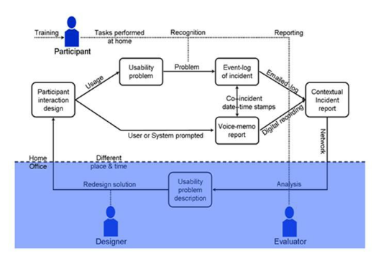
Site Navigation
Testing Site Navigation includes the testing of Menus, Buttons or Links to different pages of the website are easily visible to users and are consistent across the website.
Breadcrumb navigation should be present for providing more user friendly way to get info for path of the current page from start page.
Navigation should be easy for learning. By looking at the link's name user should get, to which page the link is navigating. The name of the links should be appropriate with simple words.
Supplemental navigation like a site map, index or a search engine.
The cursor should change to hand symbol or some suitable text format for the links, by which user can easily know that the text is in fact a hyperlink, for buttons and images also there should be animated cursors which are enabled and disables as per necessity.
Look and feel Consistency
Consistency is a factor that correlates with users’ familiarity with the application of similar nature. It is commonly termed as ‘look and feel’ of the application. Web applications for instance use a standardized login screen with a user name and a password with help on signing in problems with appropriate help content. Consistency testing checks for this standardized look and feel across the application, the uniformity in the usage of repeated visual themes and also the consistency of the theme without graphical elements.
Content Verification
Content is another important area in web application testing. This test checks for the clarity in communication of content to the target audience. Tone of the content and adapting familiar usage in language is tested here. In depth testing of content should have these parameters tested. Testing is done on spelling errors. Specific standards of User Interface on Web application exists which concentrates on fonts, colours, and frames. For example, dark colours are best avoided in the theme as it is found annoying to the users. Content testing also concentrates on location of Images and sizes of images, the anchor links presence and their connectivity to the respective pages, their placement and colour codes.
Chapter 4 describes about Accessibility Testing overview and W3C Accessibility Guidelines.
Overview
Accessibility testing is the process of evaluation against standard guidelines for the web pages and web applications. Disabled people use different type of assistive technologies to access the website and accessibility testing does the same to ensure that the website/application is supported by the assistive technologies.
The graphs exhibits a comparative understanding between the number of internet users in US and the difficulties & impairments that they face with respect to their age. The web accessibility greatly helps people of ages less than 17 and greater than 55 which covers 51.76% of the total population. This greatly ensures the dire need of making the application compliant to the respective country standards.
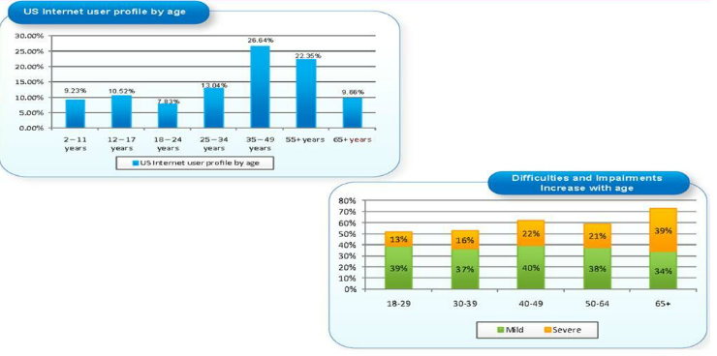
Typical accessibility problems can be classified into following four groups, each of them with different access difficulties and issues.
- Vision-The vision problems are basically blindness, low or restricted vision, or color blindness. User with visual impairments uses assistive technology software that reads content loud. User with weak vision can also make text larger with browser setting or magnificent setting of operating system.
- Dexterity-There 4 major kind of disabilities in dexterity namely tremor, paralysis, limb loss, and repetitive strain injury (RSI). It is all the inability to use a keyboard or mouse, or to make fine movements.
- Cognitive-Cognitive disorders are like dyslexia, dyscalculia, language understanding and learning difficulties such as reading difficulties or memory loss.
- Hearing-Hearing problem are basically reduced or total loss of hearing.
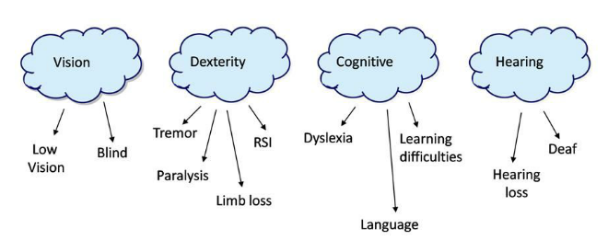
These guidelines explain how to make Web content accessible to people with disabilities. The primary goal of these guidelines is to promote accessibility. However, following them will also make Web content more available to all users, whatever user agent they are using (e.g., desktop browser, voice browser, mobile phone, automobile-based personal computer, etc.) or constraints they may be operating under (e.g., noisy surroundings, under- or over-illuminated rooms, in a hands-free environment, etc.).
The main source of accessibility guidelines is ‘Web Content Accessibility Guidelines’ (WCAG).
There are guidelines specific to countries such as USA, UK etc.. based on the percent of disabled user group living in the country.
- Section 508 Compliance in USA
- DDA Compliance in UK
WCAG is part of a series of accessibility guidelines, including the Authoring Tool Accessibility Guidelines (ATAG) and the User Agent Accessibility Guidelines (UAAG). Essential Components of Web Accessibility explains the relationship between the different guidelines.
Accessibility Testing Approach is as follows,
1. Understanding the Accessibility Test Requirements
2. Identify the checkpoints for Accessibility
3. Testing the application against WCAG guidelines manually using ‘Web Accessibility Toolbar’.
This is a manual verification of the pages against the WCAG/Section 508/DDA accessibility guidelines. The guidelines comprises of three priorities where,
Priority 1 is where a web content developer must satisfy this checkpoint. Otherwise, one or more groups will find it impossible to access information in the document. Satisfying this checkpoint is a basic requirement for some groups to be able to use Web documents.
Priority 2 is where a web content developer should satisfy this checkpoint. Otherwise, one or more groups will find it difficult to access information in the document. Satisfying this checkpoint will remove significant barriers in accessing Web documents.
Priority 3 is where a web content developer may address this checkpoint. Otherwise, one or more groups will find it somewhat difficult to access information in the document. Satisfying this checkpoint will improve access to Web documents.
4. Perform HTML & CSS validation using validators. These tests ensure that the underlying ‘code’ of the page is error free. Such errors are likely to cause rendering problems and hence accessibility issues.

5. Task based testing is a part of checkpoint verification. But, it has specific objective to conduct. In Accessibility testing, task based testing is conducted using Keyboard, Screen reader (say JAWS) and Magnifier (say Supernova).
All the above tests are conducted against specific task as follows.
- Keyboard only tasks will be conducted using the keyboard alone which reproduces the experience of a sighted user unable to use the mouse due to physical impairment (or a non-disabled user who prefers using the keyboard to the mouse).
- Create documents that do not rely on one type of hardware.
- Pages should be usable by people without mice, with small screens, low resolution screens, black and white screens, no screens, with only voice or text output, etc.
Chapter 5 describes about Graphical User Interface Testing overview, GUI Components like Text Boxes, Radio Buttons, Check boxes, Push Buttons, Drop down list boxes, Combo Box and List Boxes.
Overview
GUI (Graphical User Interface) is the front-end that serves as an interface for the end users when in any kind of information processing and data storage. GUI has virtually become the de facto standard for user interface in almost all of the modern technologies. It has become popular for several reasons like
- Easy to understand visual interface,
- Flexibility to use in most application areas,
- Choice of mouse or keyboard for the ones who find difficulty in typing,
- Visibility of multiple windows for better handling of information,
- Control of screens according to users wish and
- Seamless integration between the packaged applications and customized applications resulting in cross exchange of information.
GUI components
It becomes very essential to test the GUI components. GUI Testing can refer to just ensuring that the look-and-feel of the web application is acceptable to the end users, or it can refer to testing the functionality of each and every component involved.
The GUI components are Text Boxes, Radio Buttons, Check boxes, Push Buttons, Drop down list boxes, Combo Box and List Boxes.
Textboxes
Conditions to be checked for Text Boxes are,
- Move mouse to textbox and it should be changed to insert bar for editable text field and should remain unchanged for non-editable text field.
- Textbox Length needs to be verified by inserting the maximum possible characters in the text field.
- Enter invalid characters, special characters and make sure that there is no deviation from requirement.
- User should be able to select text using Shift + arrow keys. Selection should be possible using mouse and double click should select entire text in the text box.
Radio Buttons
Conditions to be checked for Radio Buttons are, Only one should be selected from the given option; User should be able to select any button using mouse or key board; Arrow key should set/unset the radio buttons.
Check Boxes
Conditions to be checked for Check Boxes are, User should be able to select any combination of checkboxes; Clicking mouse on the box should set/unset the checkbox; Spacebar should also do the same.
Push Buttons
Conditions to be checked for Push Buttons are,
All buttons except OK/Cancel should have a letter access to them. This is indicated by a letter underlined in the button text. The button should be activated by pressing ALT.
Clicking each button with mouse should activate it and trigger required action.
Similarly, after giving focus SPACE or RETURN button should also do the same.
If there is any Cancel button on the screen, pressing Esc should activate it.
Combo Boxes
- Pressing the arrow should give list of options available to the user. List can be scrollable but user should not be able to type in.
- Pressing Ctrl-F4 should open the list box.
- Pressing a letter should bring the first item in the list starting with the same letter.
- Items should be in alphabetical order in any list.
- Selected item should be displayed on the list.
- There should be only one blank space in the dropdown list.
- User should be able to enter text in it
List Boxes
- Should allow single select, either by mouse or arrow keys.
- Pressing any letter should take you to the first element starting with that letter.
- If there are view/open button, double clicking on icon should be mapped to these behavior.
- Make sure that all the data can be seen using scroll bar.
Condition to be checked for Combo Boxes is similar to the list mentioned above, but user should be able to enter text in it.
Conditions to be checked for List Boxes are,
Should allow single select, either by mouse or arrow keys.
Pressing any letter should take you to the first element starting with that letter.
If there are view/open button, double clicking on icon should be mapped to these behavior.
Make sure that all the data can be seen using scroll bar.
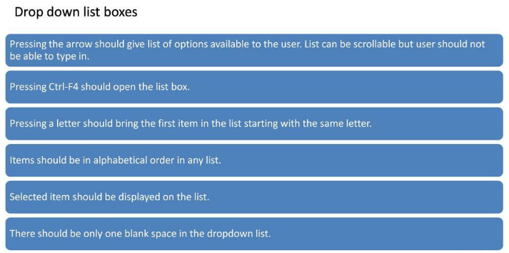 Chapter 6 describes about Interface Testing Overview, Server Interface, External Interface and Internal Interface.
Overview
Interface testing is one of the key elements in testing which ensures that the interfaces between the concerned client and servers execute in tandem. The main interfaces are Web & application server interface and Application& Database server interface. Web applications establish links between the web server and the application server at the onset. The application server in turn connects to the database server for data retrieval, processing and storage. It is an important factor that these connections or interfaces work seamlessly without any failure or degradation in performance of speed and accuracy.
Interface Analysis will be performed in the requirement analysis phases and Interface design will be performed once the Interface Analysis is completed.
Interface Development is performed after the Interface Design. Finally Interface testing is performed to ensure that the interfaces between the concerned client and servers execute in tandem
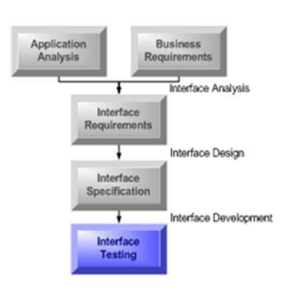
Server Interface Testing is performed
- To ensure that the communication is done correctly, web server-application server, application server-database server and vice versa.
- To ensure that the compatibility of server software, hardware, network connections.
- To ensure that the appropriate error messages are displayed; roll back in case of failure to execute or user interruption.
- To ensure that the respective interface between the web server or application or database interface captures the errors and initiates the appropriate error messages to the web application.
External Interface Testing is performed
- To ensure all the supported browsers have been tested.
- To ensure all the error conditions related to external interfaces have been tested when external application is unavailable or server inaccessible.
Internal Interface Testing is performed
- To ensure that all the linked documents are supported/opened on all platforms (i.e. can Microsoft Word be opened on Solaris)
- To ensure that the failures handled if there are errors in download
- To ensure that the tasks are getting cancelled when user leaves the site in the middle of the tasks
- To ensure that the network failures between Web site and application servers are handled
- To ensure that the intelligent error handling have been implemented (from disabling cookies, etc.)
Printer Interface Testing is performed
- To ensure that fonts, page alignment, page graphics getting printed properly.
- To ensure that the pages should be fit to paper size or as per the size mentioned in printing option.
Chapter 7 describes about Database Testing overview, Data Consistency and Integrity, Input and Output Validation, Database Queries.
Overview
Database Testing is one of the major testing which involves checking tables, writing queries and procedures. Testing can be performed in web application or desktop and database can be used in the applications like SQL, Oracle, etc. Database Testing is very important because if the backend malfunctions, it may cause system deadlock, data corruption, data loss and bad performance.
Data Consistency Testing checks the value stored in the database satisfies consistency constraints. For example, if any account number of a bank has certain balance amount. All the pages of the bank’s web application which uses the account balance should populate the same amount for that Account Number.
Data Integrity Testing verifies that converted data is accurate and functions correctly within a given application. Testing data integrity is the only way to ascertain that stored data is accurate, complete, and consistent.
Why testing at the data layers are important:
- Today’s complex software systems access heterogeneous data from a variety of backend databases.
- Corporate acquisitions make multiple database backend the norm
- Focus is on functionality, reliability, recoverability, capacity planning and scalability, performance, data accuracy
- The intricate mix of client-server and Web enabled database applications are difficult to test productively.
- All data, especially production data, should be QA'd with periodic sanity checks. Is the data “reliable”, “reasonable”, “Consistent” and “accurate”.
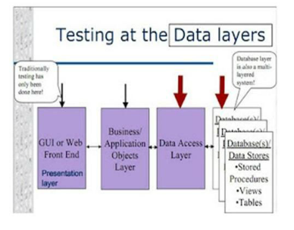
Input and Output Verification
Database Input
Validation Check is used to check for errors such as
- Wrong types of data (Entering numbers instead of text.)
- Data values that are too big or too small (Like attempting to type more than 256 words in text.)
Verification Check is used to check for
- Data accuracy.
- This is harder to operate that Validation Check because it checks if all the entered information is correct.
Database Output
Output Data Validation Testing is performed on Form View to ensure the following
- A form view displays all the record on a single file.
- Form views often have heading, labels and other items.
- Form views are used to enter data.
Output Data Validation Testing is performed on List/Table View to ensure the following
- A list/table view displays many separate records on the same screen.
- Every row is a single complete record and every column is a field.
- It is used to enter or edit data.
DB Queries
The main concept of Database testing is to validate the records that are stored in the backend, is as per the requirements. So in order to validate the records, we have to pull the records from the database and validate it against the reports generated. Records are retrieved by the Data manipulation languages in SQL and respective SQL queries can be used to perform database validation. Queries like, SELECT, INSERT, UPDATE, DELETE, etc are used to retrieve and modify the records in the database.
Output Data Validation Testing is performed on Report View to ensure the following
Reports are lists of records and selected fields and usually show the result of a search.
A report can show page numbers, headings, titles, sub-headings and dividing lines.
Reports are usually printed.
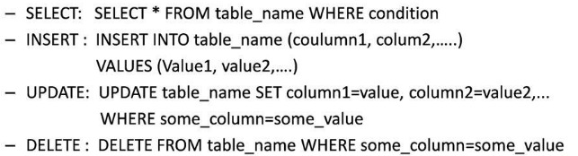
Chapter 8 describes about Compatibility Testing overview, Cross Browser Compatibility, Cross Platform Compatibility and Usage Statistics.
Overview
Compatibility testing is a critical element in Web application testing. It measures how well pages display on different software and hardware platforms; for example: different browser versions, different operating systems, and different machines. At issue are the different implementations of HTML by the various browser manufacturers, operating system support, and the different machine platform display and rendering characteristics resulting from different layout engines.
Types of Compatibility Testing are Cross Browser Compatibility Testing and Cross Platform Compatibility Testing.
CBT is Cross Browser Testing. Make sure the application works fine across multiple browsers and operating systems.
With wide range of web browsers available, end users using different web browsers to access your web applications, it has now become crucial to test web applications on multiple browsers. On different browsers, client components like JavaScript, AJAX requests, Applets, Flash, Flex, and page layout, HTML elements, W3C certification etc. may behave differently. Also for different browsers you may have different handling on how requests are processed on server side based on the user-agent received from client browser. So just testing your web application on single web browser is not enough. You need to make sure that your web application works fine across multiple browsers. Cross Browser Testing is a process to test a web applications across multiple browsers. Cross browser testing involves checking compatibility of your application across multiple web browsers and ensures that your web application works correctly across different web browsers.
Web application should be tested on all the browsers agreed by the Business team. For example, Internet Explorer, Chrome, Opera, Safari, Firefox, etc.
Cross Platform Compatibility Testing
Some functionality of the web applications may not be compatible with all operating systems. All new technologies used in web development like graphics designs, interface calls like different API’s may not be available in all Operating Systems. Operating System compatibility testing is used evaluate the performance of the web application in connection with the underlying operating system on which it will be used. Web application needs to be tested on different operating systems like Windows, UNIX, MAC, Linux, and Solaris.
Usage Statistics
Usage Statistics includes a published list of supported browsers and Operating Systems collected from the customer or project manager. If the operations team keeps statistics, the browser access report can be extracted from the live site itself. This helps us to determine what percentage of browsers and operating systems can be covered as part of the testing.
Chapter 9 describes about Content Management System Testing Overview, CMS Concept and benefits of Content Management System.
Overview
Content Management System Testing is performed to ensure that all pages of the website display correctly, links go to the specified address, and images are not broken. It is important to test the site as you build it; do not wait until just before launch to begin testing. Also, test templates as you create them so any issues are resolved before creating other content based on the templates. Recruit as many people as possible to help you test.
Here are some general site testing guidelines:
- Test on the browsers and platforms your site visitors use
- Test on a variety of monitors (for example, LCD and CRT)
- View pages using different screen resolutions
- View pages using different color settings
- Test all navigation and links
- Test items that can be downloaded (for example, PDF files)
- Test the search functionality
- Test site security
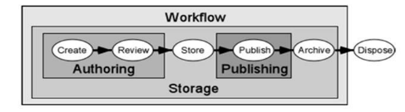
The major benefits of Content Management System are
Single source of content, Reusability of content, Versioning, Decentralized maintenance, Consistency of design is preserved, Easier authoring and publishing, Content is stored in a database and Dynamic content.
Chapter 10 describes about Web Security Testing Overview, Guidelines to be followed in web security Testing and Web Security Testing Techniques like SQL Injection, Vulnerability and Phishing.
Overview
As more and more vital data is stored in web applications and the number of transactions on the web increases, proper security testing of web applications is becoming very important. Security testing is the process that determines that confidential data stays confidential (i.e. it is not exposed to individuals/ entities for which it is not meant) and users can perform only those tasks that they are authorized to perform (e.g. a user should not be able to deny the functionality of the web site to other users, a user should not be able to change the functionality of the web application in an unintended way etc.).
Guidelines to be followed in web security Testing are
- Test by pasting internal URL directly into browser address bar without login. Internal pages should not open.
- If you are logged in using username and password and browsing internal pages then try changing URL options directly. I.e. If you are checking some publisher site statistics with publisher site ID = 123. Try directly changing the URL site ID parameter to different site ID which is not related to the logged in user. Access should be denied for this user to view others stats.
- Try some invalid inputs in input fields like login username, password, input text boxes. Check the system reaction on all invalid inputs.
- Web directories or files should not be accessible directly unless given download option.
- Test the CAPTCHA for automates scripts logins.
- Test if SSL is used for security measures. If used proper message should get displayed when user switch from non-secure http:// pages to secure https:// pages and vice versa.
- Check sessions are automatically killed after prolonged user inactivity.
Security Testing Techniques
- Few Key techniques used in security testing are Vulnerability, SQL Injection and Phishing.
Vulnerability
Vulnerability can be analyzed and handled by the following ways
- It’s a weak point thru which the security of a Computer/System can be breached.
- It’s a programming error in an application that can be exploited to gain access to the computer.
- A vulnerability does not pose an immediate threat to computers.
- Its rather a potential entry point for other threats such as viruses, worms and Trojans, which can have destructive effects.
- It’s highly advisable to keep informed about the vulnerabilities discovered in the Programs you have installed and apply the latest security patches released.
- A vulnerability assessment is a service designed to analyse the hosts in scope and find areas where attack might be more likely to occur, without necessarily exploiting the issues located.
- Specifically, a vulnerability assessment will typically involve investigation of the machine to determine whether current patches are applied, whether the system is configured in a manner that makes attack more difficult, and whether the system exposes any information that an attacker could use to gain leverage against other systems in the environment.
- Most vulnerability assessments will use a number of commercial and proprietary tools to minimize false positives, to provide action items on how to close the risks located, and will make suggestions about things the IT shop can do to make sure that the issues located don't resurface.
Web Security Testing
The inherent advantage of a vulnerability assessment is that the enterprise is looking at large number of systems and getting feedback on each of them in turn.
In other words, at the end of the process, the enterprise will ideally have some idea of the risk of attack for each of the systems surveyed using known attack methods and techniques.
Generally speaking, vulnerability assessment is a useful activity for shops that want to evaluate the processes/controls that they have in place for patch management, for secure configuration of hosts and, to some degree, security associated with system administration processes.

SQL injection
SQL injection is an often used technique to attack databases through a website. This is done by including portions of SQL statements in a web form entry field in an attempt to get the website to pass a newly formed rogue SQL command to the database. SQL injection is a code injection technique that exploits security vulnerability in a website's software. The vulnerability happens when user input is either incorrectly filtered for string literal escape characters embedded in SQL statements or user input is not strongly typed and unexpectedly executed. SQL commands are thus injected from the web form into the database of an application (like queries) to change the database content or dump the database information like credit card or passwords to the attacker. SQL injection is mostly known as an attack vector for websites but can be used to attack any type of SQL database.
Listed here are some examples of SQL Injection
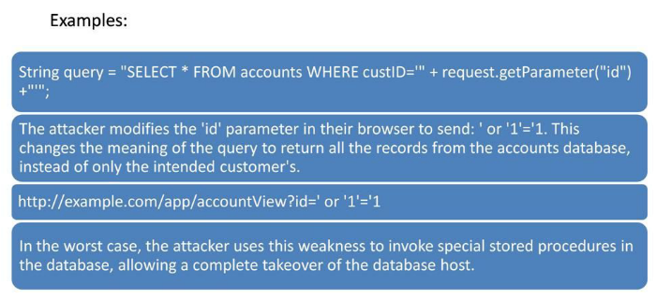
Phishing
Phishing is a way of attempting to acquire information such as usernames, passwords, and credit card details by masquerading as a trustworthy entity in an electronic communication. Communications purporting to be from popular social web sites, auction sites, online payment processors or IT administrators are commonly used to lure the unsuspecting public. Phishing is typically carried out by e-mail spoofing or instant messaging and it often directs users to enter details at a fake website whose look and feel are almost identical to the legitimate one. Phishing is an example of social engineering techniques used to deceive users, and exploits the poor usability of current web security technologies.
Chapter 11 describes about Standards Compliance Testing overview, HTML Validation and CSS Validation.
Overview
Standard Compliance followed for all Web Application are
- Application should be started by double clicking on the icon.
- Loading message should have information about application name, version number, icon etc.
- Closing of the application should result in “Are you sure?” message.
- Behaviour for starting application more than once must be specified.
- Try to start application while it is loading
- On every application, if application is busy it should show hour glass or some other mechanism to notify user that it is processing.
- Normally F1 button is used for help. If your product has help integrated, it should come by pressing F1 button.
HTML Validation
HTML is the language for describing the structure of Web pages. HTML gives authors the means to
- Publish online documents with headings, text, tables, lists, photos, etc.
- Retrieve online information via hypertext links, at the click of a button,
- Design forms for conducting transactions with remote services, for use in searching for information, making reservations, ordering products, etc, and
- Include spread-sheets, video clips, sound clips, and other applications directly in their documents.
HTML validator checks to make sure the HTML code on your web page complies with the standards set by the W3 Consortium (the organization that issues the HTML standards). There are various types of validators — some check only for errors; others also make suggestions about your code, telling you when a certain way of writing things might lead to (say) unexpected results.
CSS Validation
- CSS is the language for describing the presentation of Web pages, including colors, layout, and fonts. It allows one to adapt the presentation to different types of devices, such as large screens, small screens, or printers. CSS is independent of HTML and can be used with any XML-based markup language. The separation of HTML from CSS makes it easier to maintain sites, share style sheets across pages, and tailor pages to different environments. This is referred to as the separation of structure (or: content) from presentation.
- A CSS validator checks your Cascading Style Sheets in the same manner; basically, most will check them to make sure that they comply with the CSS standards set by the W3 Consortium. There are a few which will also tell you which CSS features are supported by which browsers (since not all browsers are equal in their CSS implementation).
Chapter 12 describes about Performance Testing overview, Testing Types like Performance Testing, Load Testing, Stress Testing, Capacity Testing and Performance Testing Tools like SilkPerformer, Rational Performance Tester, Qtest and HP LoadRunner.
Overview
Performance testing is the process of determining the speed or effectiveness of a computer, network, software program or device. This process can involve quantitative tests done in a lab, such as measuring the response time or the number of MIPS (millions of instructions per second) at which a system functions. Qualitative attributes such as reliability, scalability and interoperability may also be evaluated. Performance testing is often done in conjunction with stress testing. Performance testing can verify that a system meets the specifications claimed by its manufacturer or vendor. The process can compare two or more devices or programs in terms of parameters such as speed, data transfer rate, bandwidth, throughput, efficiency or reliability. Performance testing can also be used as a diagnostic aid in locating communications bottlenecks.
A performance test is a technical investigation done to determine or validate the responsiveness, speed, scalability, and/or stability characteristics of the product under test.
Benefits of Performance Testing are
- Determines the speed, scalability and stability characteristics of an application, thereby providing an input to making sound business decisions.
- Focuses on determining if the user of the system will be satisfied with the performance characteristics of the application.
- Identifies mismatches between performance-related expectations and reality.
- Supports Tuning, Capacity Planning and Optimization efforts.
Load Testing
Load Tests are end to end performance tests under anticipated production load. The objective such tests are to determine the response times for various time critical transactions and business processes and ensure that they are within documented expectations (or Service Level Agreements - SLAs). Load tests also measures the capability of an application to function correctly under load, by measuring transaction pass/fail/error rates.
Purpose of a Load Test?
- Quantification of risk - Determine, through formal testing, the likelihood that system performance will meet the formal stated performance expectations of stakeholders, such as response time requirements under given levels of load. This is a traditional Quality Assurance (QA) type test. Note that load testing does not mitigate risk directly, but through identification and quantification of risk, presents tuning opportunities and an impetus for remediation that will mitigate risk.
- Determination of minimum configuration - Determine, through formal testing, the minimum configuration that will allow the system to meet the formal stated performance expectations of stakeholders - so that extraneous hardware, software and the associated cost of ownership can be minimized. This is a Business Technology Optimization (BTO) type test.
The important thing to understand in executing such a load test is that the load is generated at a protocol level, by the load generators, that are running scripts developed with the VUGen tool. Transaction times derived from the VUGen scripts do not include processing time on the client PC, such as rendering (drawing parts of the screen) or execution of client side scripts such as JavaScript. The WinRunner PC(s) is utilized to measure end user experience response times. Most load tests would not employ a WinRunner PC to measure actual response times from the client perspective, but is highly recommended where complex and variable processing is performed on the desktop after data has been delivered to the client.
The LoadRunner controller is capable of displaying real-time graphs of response times as well as other measures such as CPU utilization on each of the components behind the firewall. Internal measures from products such as Oracle, WebSphere are also available for monitoring during test execution.
After completion of a test, the Analysis engine can generate a number of graphs and correlations to help locate any performance bottlenecks.
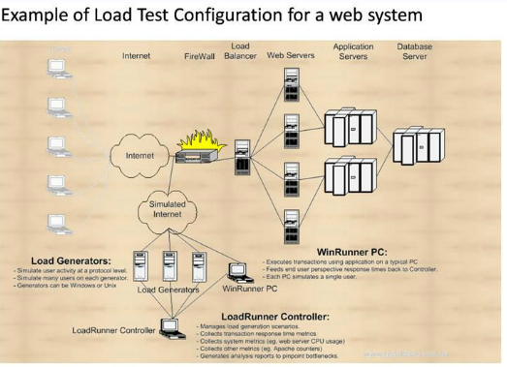
Stress Testing - Stress Testing is performed to identify the application defects that surface only under high load conditions like synchronization issues, race conditions and memory leaks. Stress testing identifies the web application’s weak points, and shows how the application behaves under extreme load conditions.
Approach for Stress Testing
The following steps are involved in stress-testing a Web application:
Step1 - Identify test objectives. Identify the objectives of stress testing in terms of the desired outcomes of the testing activity.
Step 2 - Identify key scenario(s). Identify the application scenario or cases that need to be stress-tested to identify potential problems.
Step 3 - Identify the workload. Identify the workload that you want to apply to the scenarios identified during the “Identify objectives” step. This is based on the workload and peak load capacity inputs.
Step 4 - Identify metrics. Identify the metrics that you want to collect about the application’s performance. Base these metrics on the potential problems identified for the scenarios you identified during the “Identify objectives” step.
Step 5 - Create test cases. Create the test cases in which you define steps for running a single test, as well as your expected results.
Step 6 - Simulate load. Use test tools to simulate the required load for each test case and capture the metric data results.
Step 7 - Analyze results. Analyze the metric data captured during the test.
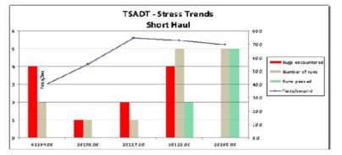
Capacity testing
Capacity testing is conducted in conjunction with capacity planning, which is used to plan for future growth, such as an increased user base or increased volume of data. For example, to accommodate future loads, you need to know how many additional resources (such as processor capacity, memory usage, disk capacity, or network bandwidth) are necessary to support future usage levels.
Capacity testing helps you to identify a scaling strategy in order to determine whether you should scale up or scale out.
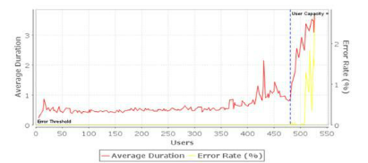
Benefits of Capacity Testing are
- Provides information about how workload can be handled to meet business requirements.
- Provides actual data that capacity planners can use to validate or enhance their models and/or predictions.
- Enables you to conduct various tests to compare capacity-planning models and/or predictions.
- Determines the current usage and capacity of the existing system to aid in capacity planning.
- Provides the usage and capacity trends of the existing system to aid in capacity planning
Performance testing tools
SilkPerformer is an enterprise-class tool for software application performance and load testing. It provides automated software load, stress and performance testing in an open and sharable model. With SilkPerformer, you can create powerful, realistic load tests for thousands of users running business scenarios across a broad range of enterprise application environments to identify bottlenecks, and then apply powerful diagnostics to resolve performance issues.
Rational Performance Tester can be used to identify the presence and cause of system performance bottlenecks. Rational Performance Tester goes beyond problem identification to problem diagnosis. Using Root Cause Analysis features, you can identify both the source code and physical application tier that is causing the bottleneck.
Qtest integrates into the entire application development and quality control cycle. Operating anomalies are identified and analyzed to allow for immediate correction. Any bottlenecks are eliminated. Qtest allows testing of a wide range of project types and in different environments.
HP LoadRunner allows you to prevent application performance problems by detecting bottlenecks before a new system or upgrade is deployed. It lets you deploy quality applications with confidence and enables consistent repeatable testing processes.
Chapter 13 describes about Device Testing Overview, Mobile Platforms and Devices, Simulators
Overview
Similar to general Software Testing, Mobile Software Testing also includes
- User Interface Testing to check Color scheme, Menu styles, Consistency of UI over various Devices.
- Functional Testing to ensure core functionality of Mobile App as per specification.
- Performance & Stress Testing to analyze the behavior of Mobile Application in Low resources, Behavior of mobile website when many mobile user simultaneously access mobile website.
- Testing Usability aspects of Mobile Apps.
Device Testing
Compatibility testing: Compatibility testing assures that a given application works as intended with selected devices with different screen sizes, resolutions, and internal hardware (memory size, processor speed, and button/input differences). AppLabs defines the feasible compatibility combinations of devices and interfaces for a specific testing assignment, in concurrence with the customer’s requirement.
Interoperability testing: Interoperability testing includes testing of different functionalities on different mobile agents such as messaging, call setup, sharing conference, and video messaging etc.
Functionality testing: Functionality testing of a mobile device includes controls, storage media handling options, and other operational aspects. Functionality testing of a mobile application is a black-box type of testing to assure that the application is functioning as per the business specifications.
Usability testing: Usability testing encompasses mobile interface testing, application navigation testing, and intuitiveness of the application, consistency, and soberness of color scheme. AppLabs studies the usability designs; task analysis, and alpha charts of an application as part of the product knowledge transfer and assures the usability requirements of the application are fulfilled.
Performance testing: AppLabs performs the load, capacity, and stress testing of mobile application servers. The objective of load testing is to determine whether the application can sustain the required number of users with acceptable response times. The objective of capacity testing is to benchmark the maximum load of concurrent users an application can sustain before experiencing system failure while the objective of stress testing is to validate an application’s stability and reliability over an extended period of time.
Localization and Internationalization testing: The objective of this testing is to assure that the localization and internationalization features are supported by the devices and applications as per specifications. Communication testing: The objective of communication testing is to verify the protocols and handshakes in a call flow between multiple users.
Data exchange and synchronization testing: This testing focuses on data exchange and synchronization among different mobile devices, PDAs, and PCs using infrared frequency and USB ports.
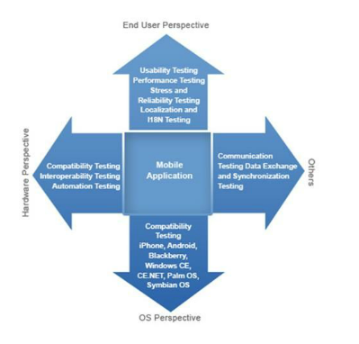
Mobile Platforms & Devices
Testing capabilities for all major mobile based platforms including iOS for iPhone, iPod, iTouch, Android for Smartphones and Tablets, Windows Phone, Blackberry and WebOS.
Simulators always play big role when there are no mobile devices available for testing. Though Device testing is always preferred as it represents more likely end user scenarios, the importance of simulators cannot be ignored. In order to have effective testing over Simulator, It is recommended to explore all the capabilities of Simulator.
The major benefits of Content Management System are
Single source of content, Reusability of content, Versioning, Decentralized maintenance, Consistency of design is preserved, Easier authoring and publishing, Content is stored in a database and Dynamic content.
Glossary
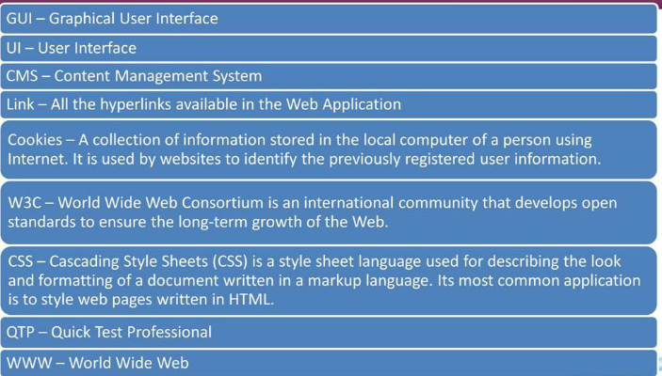
Questions
